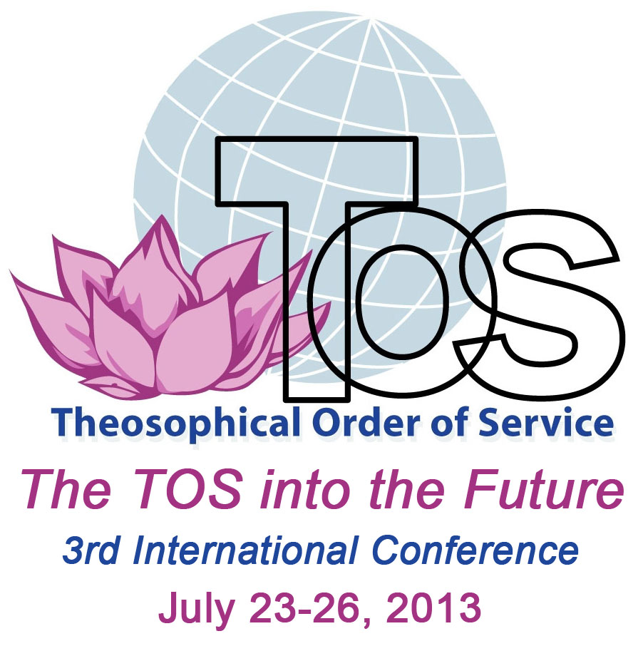
Third TOS International Conference
Venue: ‘Olcott’, Wheaton, Illinois, USA
Theme: The TOS into the Future
Tuesday, July 23 – Friday July 26, 2013
(Meals and refreshments in the dining hall; all meetings in the auditorium)

TUESDAY, July 23

3:00–5:00 Registration

5:30 Evening meal

7:30–8:15 Opening of the 3rd International TOS Conference
Invocation: Maria Parisen
Words of welcome:
National President of the host Section, Tim Boyd
National President of the TOS USA, Nancy Secrest

Keynote thoughts: International Vice-President of the TS, Mahendra P. Singhal

Conference overview: Carolyn Harrod, Conference Convenor

8:15–9:00 Locks of Love: a simple act of service

WEDNESDAY, July 24

7:30–8:15 Breakfast
9:00–10:15 Attunement: Maria Parisen

Address: “The TOS 100 years from now” by Vicente Hao Chin, Jr., Trustee, TOS Foundation in the Philippines

10:45–11:45 Orientation session: Carolyn Harrod

12:00 Lunch
2:00–3:30 First plenary session: “The TOS into the Future: What has been achieved in the past five years?”

5:30 Evening meal

7:30–8:45 Choice of service-related workshops (first session):
- “Serving with the eyes of spirit”: Dorothy Bell
- “Tapping the amazing potential of volunteers”: Carolyn Harrod & Jean Carroll
- “Deep listening”: Maria Parisen
- “Service and the Spiritual Life”: Vic Hao Chin, Jr.

THURSDAY, July 25

7:30–8:15 Breakfast
9:00–10:15 Address: “Creative Meditation: Balancing Inner and Outer Action”: Maria Parisen, Director, Krotona Institute School of Theosophy

10:45–11:45 Second plenary session: “The TOS into the Future: Planning for the next five years”

12:00 Lunch

2:00–3:00 Choice of service-related workshops: opportunity to attend a second workshop
5:30 Evening meal

7:30–8:45 Group discussion: Rising to the challenges we face in our TOS work

FRIDAY, July 26

7:30–8:15 Breakfast
9:00-10:15 Attunement: Maria Parisen

Short talks: “Service as sacred labour”

10:45–11:45 Third plenary session: “The TOS into the Future: Commitments to action”

12:00 Lunch
2:00–3:00 Concluding session
5:30 Evening meal

SATURDAY, July 27: Departures

