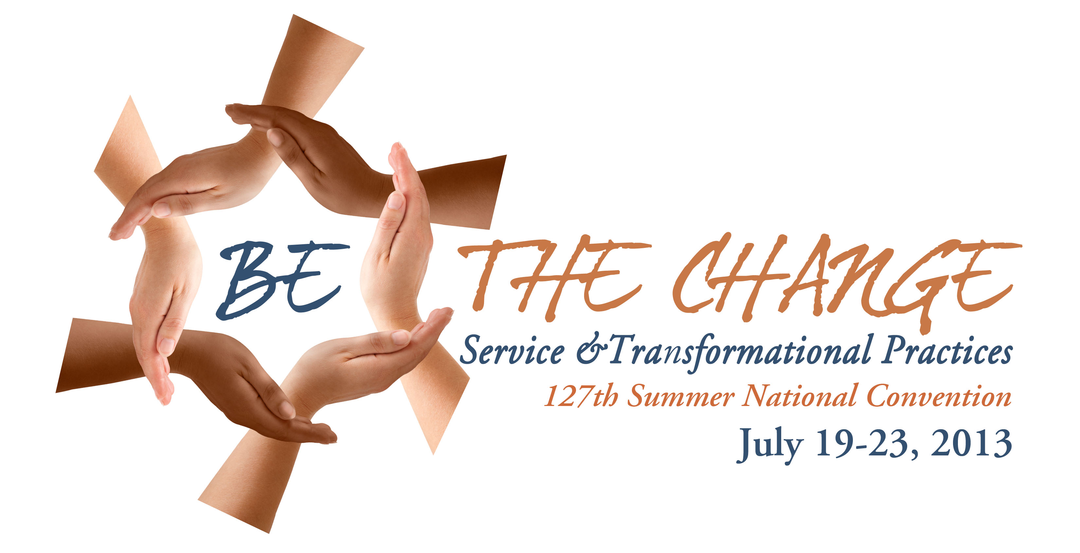

FRIDAY, July 19

1:00–2:00 Discussion Group Leaders’ Orientation
2:00–3:00 TOS Members meeting
3:00-3:30 TOS Liaisons meeting
2:00–5:00 Registration (Classroom)
4:00 Guided walking tour of the grounds and buildings (start in Lobby)
Meeting for ES members
5:30 Supper (Nicholson Hall)
7:30 Opening of the 127th Annual Meeting: Invocation, Prayers of the
Religions, Welcoming, Introductions, Greetings from international and local groups,
Credentials Committee Report, and Announcements
Social Gathering (Nicholson Hall)

SATURDAY, July 20

7:00 Yoga
7:45–8:30 Breakfast (Nicholson Hall)
8:45–9:00 Meditation
9:15–10:30 Public Lecture – “Make me an Instrument of your Peace”: The amazing encounter of St. Francis of Assisi and the Sultan, Malek al-Kamil during the violence of the Crusades by Sister Gabriele Uhlein
10:45-11:45 Public Lecture by Vic Hao Chin Jr.
12:00 Lunch (Nicholson Hall)
2:00–3:00 Public Lecture – Finding the Sacred Ground in a Troubled World by Cynthia Overweg
3:00-3:30 Break
3:30-5:00 Public Lecture - A Destiny in Common: Energetic activism of the sake of all life
with Sister Gabriele Uhlein
5:30 Supper (Nicholson Hall)
7:00 Cultural night
Social gathering (Nicholson Hall)

SUNDAY, July 21

7:00 Yoga
7:45–8:30 Breakfast
8:45-9:00 Meditation

SUNDAY, July 21 (continued)

9:15-12:00 Activity Reports / Business meeting – all invited
12:00 Lunch
2:00-3:00 Public Lecture – Mindfulness in the World: Health & Healing through Right Perception
by Fernando de Torrijos
3:00-3:45 Special Tea Time with the “Olcott family”
3:45-4:45 Public Lecture or Video screening
4 4:45-5:30 Discussion Groups
5:30 Supper
7:00 Fun Night
Social gathering (Nicholson Hall)

MONDAY, July 22

7:00 Yoga
7:45-8:30 Breakfast
8:45-9:00 Meditation
9:15-10:15 Public Lecture – Working with the Wisdom: a Living Power by Dorothy Bell
10:45-11:45 Short talks: Patrizia Calvi: The Gift of Service; Usha Shah: Empower a woman and we empower the universe! and Dr. Deepa Padhi: Look Within To Reach Out
12:00 Lunch
2:00-3:30 Workshop: A Mindful Approach to Emotional Healing with Fernando de Torrijos
3:30-4:30 Discussion Groups
5:30 Supper
7:00 TOS Powerpoint: Theosophists in Action! with Diana Dunningham Chapotin
Social gathering (Nicholson Hall)

TUESDAY, July 23

7:00 Yoga
7:45–8:30 Breakfast
8:45–9:00 Meditation
9:15–10:30 Members Lecture by Vic Hao Chin Jr.
10:45–11:45 Panel Discussion – Vic Hao Chin Jr., Dorothy Bell, and Fernando de Torrijos
(moderated by Tim Boyd)
11:45 Closing: TSA President
12:00 Lunch
1:00 Socializing and leave-taking

Meals and refreshments in the Nicholson Hall; all meetings in the Auditorium, except as indicated.
Bargain Book Sale at Quest Book Shop throughout the Conference
***Archival Display and Art Exhibit during the entire conference***

